1. **Voltage Follower**

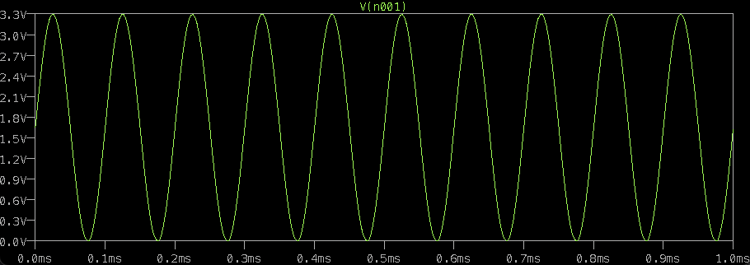

**Sine curve from 0 to 3.3 V with 10kHz frequency**

**Sine curve from 0 to 3.3 V with 100kHz frequency**

1. **Inverting Amplifier**

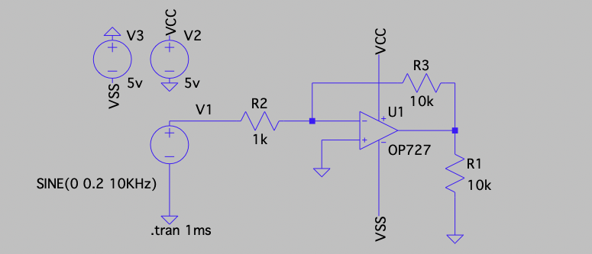

**Circuit**

**Simulation Result**

1. **Non-inverting amplifier**

**Circuit**

**Simulation Result**

1. **Current Source**

**Circuit**

**Simulation Result**